**Effects of Greenhouse Gasses on Global Temperature**

Tyki Wada

Analysis done as example, not for valid use or publication.

Table of Contents

Summary ……………………………………………………………………………………………………………………………. pg. 3

Data …………………………………………………………………………………………………………………………………. pg. 4

Forecasting of Temperature and Greenhosue Gasses …………………………………………….. pg. 4

Regression Statistics……………………………………………………………………………………………….. pg. 6

Analysis ……………………………………………………………………………………………………………………………… pg. 7

Sources ………………………………………………………………………………………………………………………………. pg. 8

Climate Effect Model

**Summary:**

Given the debate on Global warming and the effect of greenhouse gasses on the environment, a model has been created using public data collected by both NASA1 and the Maunaloa2 Observatory to make inference on how greenhouse gasses affect the temperature. Gasses of interest were gathered from the [Environmental Protection Agency](https://www.epa.gov/ghgemissions/overview-greenhouse-gases) website and scraped from NASA and Maunaloa datasets. The overall model contains only Methane and Carbon Dioxide for maximum prediction ability. The results show an overall increase in temperature from both types of greenhouse gasses.

Climate change is a fundamental problem involving basic statistical knowledge. Much research is still necessary before we may assess certainty about all aspects of climate change to plan for the future. Predictions of future climate change, based on regression and time series Analysis (global climate models), are critical outputs for climate science.

Overall, the data has indicated that there is indeed a positive effect of greenhouse gasses (methane and CO2) on overall temperature (p-values and effect metrics included in analysis). However, not included in this analysis are other greenhouse gasses (SF6 , HCFC, and N2O) which show individual positive effects with temperature, but could not be included in this model due to high correlative interference with other data points. This model has been created to produce the highest prediction power with safe assumptions in explaining the effect of greenhouse gasses on temperature.

Future research will need to include different models for higher accuracy in prediction. This is made in hopes to clarify general statistical evidence for the temperature climate debate.

**Data:**

**Frequency Data**

Below is the Time Series Data of the trends in Temperature, CO2 , and methane. All indicate future predictions for the next 5 years.

If trends continue just as recent data has shown, these are the graphs and forecasted values for Temperature (C˚), methane (ppm), and CO2 (ppm) in respective order

Prediction values have been made using a time series method including values starting at 2010 to present. 2010 was included to indicate a possible unforeseen jump in future values.

Temperature Frequency from 1999 to 2021



CO2  Frequency from 199 to 2021



Methane Frequency from 1999 to 2021



**Regression Statistics**

Below are the regression statistics that give prediction values of temperature on each type of greenhouse gas.

| mean | | Standard deviation | correlation |
| --- | --- | --- | --- |
|  |  |  |  |
| co2 | 386.164339 | 11.020916 | 0.5998160 |
| methane | 1809.901164 | 27.517525 | 0.6287320 |

Table values of CO2 and Methane with Temperature data in Celsius.

Histogram of the residuals

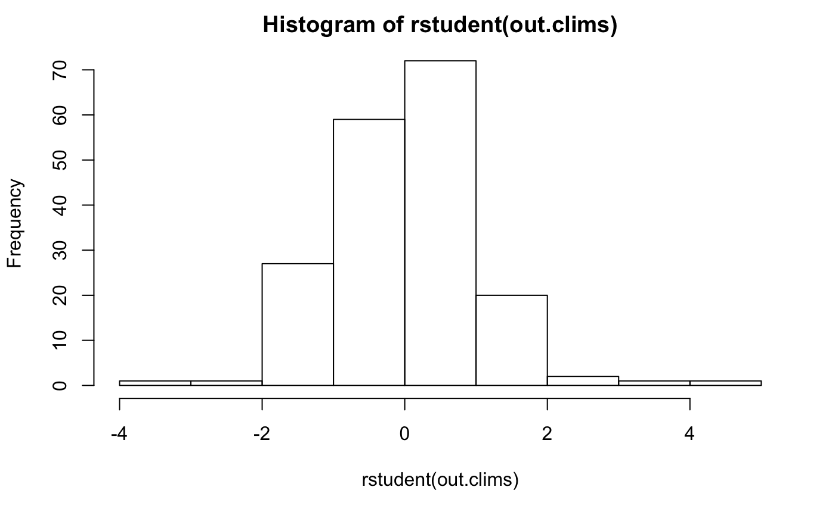

R2 value: 0.4539

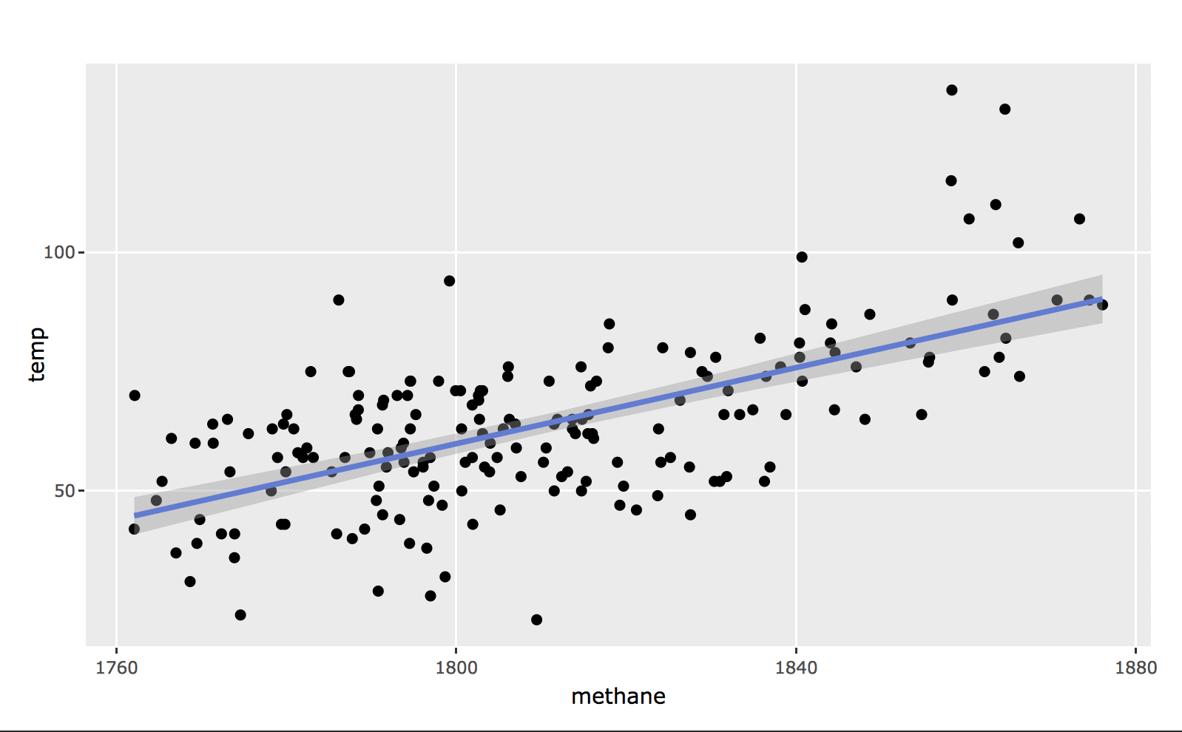These values show that there are no huge spikes in data irregularities (outliers and influential observations). Correlation values indicate a high positive strength with temperature. Scatterplots of the individual gasses are shown below. These reflect the correlation values on the table above.

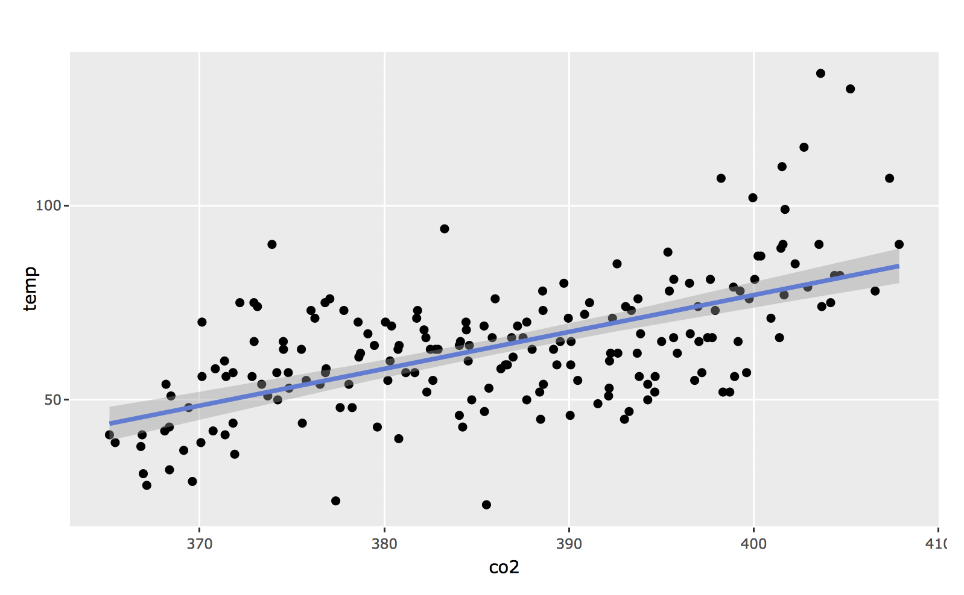

| ß values | | P-value (alpha = 0.05) | Standard Error |
| --- | --- | --- | --- |
|  |  |  |  |
| CO2 | 0.3959 | 0.0129 | 0.4539 |
| methane | 0.2734 | < 0.0001 | 0.4 |

**Analysis:**

Overall, we see a stark increase in the frequency of greenhouse gasses and temperature with a very constant trend that begins from 2010 to present. Previous values had tended to vary year to year showing some natural variation, but recent values have shown more predictable qualities. These anomalies must be investigated further.

There is an interesting phenomenon indicating the trends in both methane and CO2 values. Both the trends show a seemingly similar trend and oscillation. This means that though the number of particles differ in scale, the levels of greenhouse gasses for CO2 and Methane are relatively similar from year to year. This is an important indicator as we notice the increase in one greenhouse gas seems to rise and fall very similarly with another from year to year. There will be further investigation to see if there truly is a statistical difference between ALL types of gasses in the future.

For a more in-depth analysis, a climate statistician may need to be consulted with as a frame of reference may be necessary to determine how typical these trends are and how macro or miniscule these particle measurements are from past to present. We still cannot disagree that the CO2, temperature, and methane values have increased in a different

As for individual greenhouse gas effects on temperature:

The last table above shows the output for the regression model:

* ***CO2***: For every one-unit increase in carbon dioxide (in ppm), we expect a 0.3959 degree increase in temperature (C˚) holding all other effects constant.

P-Value < 0.0001 (CI 95%: 0.08466712 , 0.7071018)

* ***Methane*:** For every one-unit increase in methane (in ppm), we expect a 0.3959 degree increase in temperature (C˚) holding all other effects constant.

P-Value < 0.0001 (CI 95%: 0.14887888 , 0.3978922)

This supports the claim that there is indeed a positive effect of greenhouse gasses (CO2 & Methane) on temperature. A cross examination with ozone and other environmental data may validate the severity of the climate change.

The overall power of prediction in this model is given by the R2 value: 0.454 which indicates that the regression model explains about 45.5% of the variability in the CO2 and methane data. This is a high value, but still shows that we have incomplete information to explain all the changes in the temperature model. Regardless, the power to address the accuracy of the effects with the gasses are very strong as shown by the p-values above.

For more accurate information and explanation in variability, a different type of analysis will be necessary requiring the interactions between different types of gasses. This must be done by finding more factor-levels (categorical information) that separate the different types of gasses into more granular groups. Some ideas for new types of collections methods may include: Time of year (month), time of day, location of collection, degree of greenhouse emission levels. New methods of collection will most likely be the best way to have higher degrees of prediction using more greenhouse gasses.

**Sources:**

Retrieved: 02/21/2018

1. Climate Data:

* Monthly Global Mean Land-Ocean Temperature Data (1880-Present)
  + <http://data.giss.nasa.gov/gistemp/tabledata_v3/GLB.Ts+dSST.txt>

1. Greenhouse gasses from Mauna Loa Observatory, Hawaii:

* Monthly mean atmospheric CO2 concentration expressed as micromol per mole and abbreviated as ppm
  + <ftp://aftp.cmdl.noaa.gov/data/trace_gases/co2/flask/surface/co2_mlo_surface-flask_1_ccgg_month.txt>
* Monthly mean atmospheric CH4 concentration expressed as micromol per mole and abbreviated as ppm
  + <ftp://aftp.cmdl.noaa.gov/data/trace_gases/ch4/flask/surface/ch4_mlo_surface-flask_1_ccgg_month.txt>
* Monthly Atmospheric N20 Concentration expressed as micromol per mole and abbreviated as ppb
  + <ftp://aftp.cmdl.noaa.gov/data/hats/n2o/insituGCs/CATS/monthly/mlo_N2O_MM.dat>
* Monthly Atmospheric Hydrochloroflurocarbon Concentration expressed as micromol per mole and abbreviated as ppb
  + <ftp://aftp.cmdl.noaa.gov/data/hats/hcfcs/hcfc142b/insituGCs/CATS/monthly/mlo_HCFC142b_MM.dat>
* Monthly atmospheric sulfer hexaflouride (SF6) Concentration expressed as micromol per mole and abbreviated as ppt
  + <ftp://aftp.cmdl.noaa.gov/data/hats/sf6/insituGCs/CATS/monthly/mlo_SF6_MM.dat>